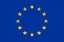
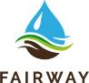

Funded by the Horizon 2020
Framework Programme of the European Union
(Grant Agreement 727984 / 727450)

Launch Event for Policy Makers and Stakeholders. Brussels 6th December 2017

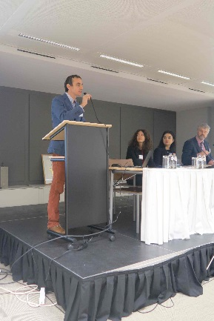
FAIRWAY and WaterProtect are two projects aiming to protect drinking water resources from pollution by pesticides and nitrates. Both projects recently started under the EU Research and Innovation programme Horizon 2020. A launch meeting for policy Makers and stakeholders was held in Brussels on 6th December. Gaëtan Dubois (DG Agri) is the policy officer of both projects and he chaired the meeting. There were 32 participants from the European Commission, the water sector, and the agricultural sector.

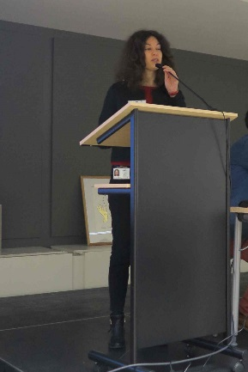
Lara Passante (Research Executive Agency REA) presented, on behalf of the project officers Arantza Uriarte and Lara Congiu, the background of the call for these projects. The impacts of the projects expected by the commission include cooperation between stakeholders, involvement of farmers and other citizens in monitoring of water quality, new water governance models, and an integrated scientific support for relevant EU policies. The two projects are financed under the topic RUR-04-2016 “Water Farms – improving farming and its impact on the supply of drinking water”. The EU Contribution is approximately 5 Million Euros for each project. The project falls under the concept of the 'multi-actor approach'. (»See presentation)

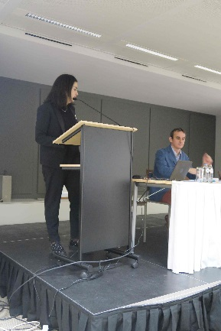
Claudia Muresan (DG Agri) and Gerard Shortle (DG Env) are contact persons of the task force water of DG Agri and DG Env. This task force was set up in December 2015 by the Commissioners Hogan (DG Agri) and Vella (DG Env) to improve the economic and environmental performance of farms and the long-term availability of water. The aims of the task force include facilitating joint actions within the current legal framework, catalysing new work on research, innovation, investments, and governance and promoting new financial resources. In May 2017 a staff working document on agriculture and sustainable water management in the EU was published. Reinforcement of the coordination between relevant EIP water and EIP-AGRI groups was indicated as one of the important items related to knowledge transfer. (»See presentation)

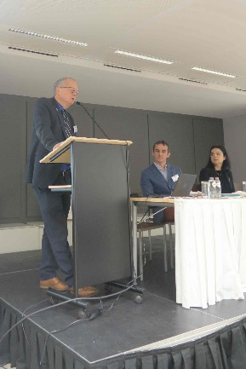
Arjen Frenz (EurEau) presented the water industry perspective of water quality and agriculture. EurEau is the voice of Europe’s water sector since 1975 and represents public/private drinking/waste water services from 29 European countries. He indicated that a better implementation of existing EU legislation is needed. Cooperation between water utilities and farmers is key and more financial support of EU is needed for upscaling cooperation initiatives to increase the impact. Cooperation on voluntary basis is not enough. EurEau has launched a proposal on “blueing measures” for the future CAP, which consists of five topics, i.e. i) Plant nutrition and fertilization, ii) Land utilisation and cultivation, iii) Plant protection (pest management), iv) Water management, and v) Organisation and management. (»See presentation)

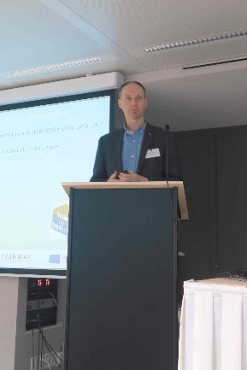
Gerard Velthof, coordinator of FAIRWAY presented the general aims of Fairway and WaterProtect: to contribute to a more effective protection of drinking water resources against nitrate and pesticide pollution from agriculture by identification and further development of innovative measures and governance approaches, together with relevant local, regional and national actors. There are in total 20 regional cases in both projects; 13 FAIRWAY case studies/multi-actor platforms and 7 WaterProtect action labs. FAIRWAY has 22 partners in 11 countries. FAIRWAY is based on scientific reviews and the experiences in the case studies and actors in the Multi-Actor Platforms. The expected impacts of FAIRWAY includes innovative and effective measures, practices and indicators, easy-to-use tools for farmers, improved governance approaches for drinking water protection, and improved science-policy interface. (»See presentation)

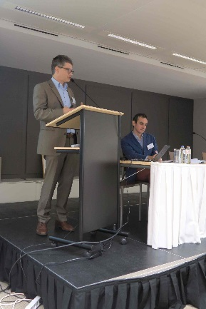
Piet Seuntjens, coordinator of WaterProtect presented the action lab approach within WaterProtect to come to effective implementation of mitigation measures to improve water quality in rural areas. WaterProtect consists of 7 action labs where farmers, water managers, research and drinking water producers work together. Activities in the action labs include participatory monitoring, governance strategies and alternative financing, best management practices and collaborative tools to facilitate exchange of information. WaterProtect aims to install 13 mitigation measures, to have a full participatory monitoring started in the 7 action labs and to have hundreds of interactions through the webtools. The experience in action labs will be shared among the action labs and will form the basis for upscaling the information to the EU and to deliver concrete policy advice. (»See presentation)

General discussion
DG research recommends mutual progress reports of both projects FAIRWAY and WATERPROTECT, and to organize regular meetings between principal partners in both projects. In addition, it is recommended organizing joint policy advice meetings with EU stakeholders, having stakeholders to present cases. Storylines from case studies and action labs from both projects should be presented in future events. Engagement and cooperation at the local level is needed and especially for hot spot areas. Involvement of food companies is needed as well, because they make claims on the impact of their products. A mix of legal instruments is not always working properly. The task force water indicates that cross compliance is important and more measures for the Water Framework Directive are needed in cross compliance.

