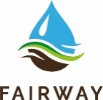
Main barriers and solutions for creating safe drinking water resources
FAIRWAY Workshop, Tuesday 4 June 2019. LuWQ2019 Aarhus

Background and aim

Safe drinking water is vital for human health and the economy. Throughout the EU, diffuse pollution of nitrogen and pesticides from agriculture is the main obstacle to meeting the drinking water quality targets.

The general objective of the H2020 project FAIRWAY (https://www.fairway-project.eu/) is to review current approaches and measures for protection of drinking water resources against nitrate and pesticide pollution in the EU, and to identify and further develop innovative measures and governance approaches for a more effective drinking water protection.

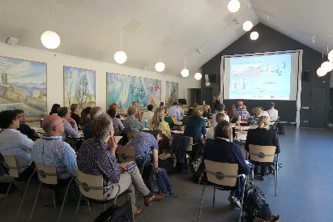
FAIRWAY organized a workshop on the main barriers and solutions for creating safe drinking water resources during the Conference on Land Use and Water Quality in Aarhus (June 2019). The aim of the workshop was to discuss and rank the main barriers and solutions for creating safe drinking water resources.

29 people from 12 countries participated in the workshop:
7 NL, 5 DE, 4 DK, 2 Sl, 2 NO, 2 CH, 2 GB, 1 LV, 1 FI, I FR, 1 BE, 1 AT

Note: the results presented in the following minutes should be read as the opinion of the conference visitors, and not as the result of thorough scientific research.

Set-up

All participants were asked to rank:
- the main barriers for creating safe drinking water resources in EU,
- the main solutions for creating safe drinking water resources in EU, and
- the main technical measures to decrease nitrate and pesticide pollution.
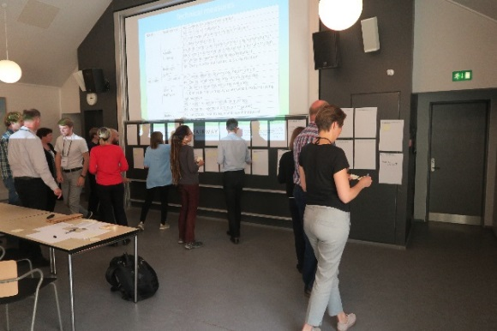
Lists with barriers, solutions, and measures were prepared by members of the FAIRWAY project. Some additional options were added by participants of the workshop.

All participants received three stickers for each topic to score the most important barriers and solutions.

The results were ranked and the main barriers and solutions were discussed with the participants.

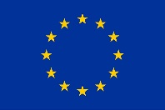
This project has received funding from the European Union’s Horizon 2020 research and innovation programme under grant agreement No 727984

Results

The tables on the following pages show the results.

The main barriers for creating safe drinking water resources in EU are:
- Financial barriers (lack of funding) to apply certain measures
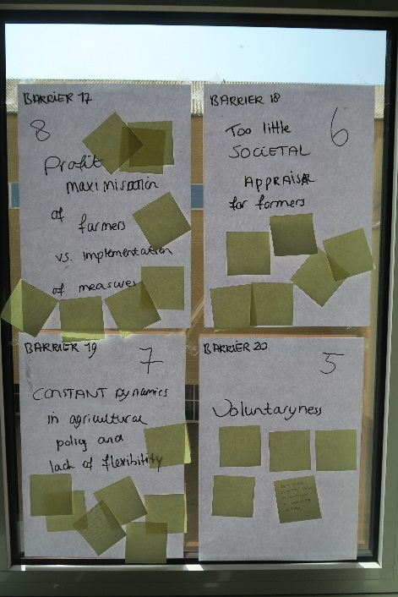
- (Lack of) enforcement of rules
- Site specific aspects; best managed practise is often to general
The main solutions for creating safe drinking water resources in EU are:
- More effective enforcement
- Subsidies to apply certain measures
- More collaboration between farmers, scientists, stakeholders and policy makers
The main measures to decrease nitrate leaching in EU are:
- Changes in farm structure, e.g. crop rotation
- Balanced nitrogen fertilization
- Buffer strips and riparian zones along water courses
The main measures to decrease nitrate leaching in EU are:
- Integrated Pest management; combination of measures at farm
- Row application, lower dose, better timing
- Choice for alternative, less harmful pesticide

The results show that the participants ranked enforcement and financial barriers and solutions as highest.

The EU has developed a series of directives to improve water quality, such as Water Framework Directive, Nitrates Directive, Drinking Water Directive, and Sustainable Use of Pesticides Directive. The rules and measures of these directives have to be implemented on a national or regional scale. Effective enforcement mechanisms are needed to ensure a positive contribution of the directive to improvement of water quality. However, enforcement of rules is often lacking.

Part of the measures to decrease nitrate and pesticide leaching are expensive and have no clear economic benefit for the farmers. Environmental protection motivates only a minority of farmers to take measures. Subsidies can help to apply effective measures to improve water quality.

The participants of the workshop indicate that for both nitrates and pesticides, changes in farm structure and integrated management are the most promising measures to improve water quality. Some technical measures are only effective in combination with other measures. These results indicate that structural changes in farm systems (redesign the system), e.g. by changes in crop rotation, may be more effective to improve water quality than technical measures.

The lists of priority barriers, solutions and measures will be taken into account in the FAIRWAY project while (further)developing innovative measures and governance approaches for a more effective drinking water protection.

Please subscribe the FAIRWAY newsletter for more information about activities and results: https://www.fairway-project.eu/

Barriers for creating safe drinking water resources in EU
 | Title | Score
Governance | B1 Complexity of regulations and policy | 3
 | B2 Incoherence and inconsistency of rules and laws | 6
 | B3 (lack of) enforcement of rules | 10
 | B4 Knowledge policy makers | 7
 | B5 Need for clearly defined indicators | 1
 | B6 Lack of local governance arrangements | 0
Measures | B7 Not clear what the most effective measure is in specific cases | 6
 | B8 Financial barriers (lack of funding) to apply certain measures | 11
 | B9 Long time lag between action and effect on water quality | 1
 | B10 Manure/fertilizers too cheap | 1
 | B11 Site specific aspects; best managed practise is often to general | 8
Application in practice | B12 Socio-cultural factors; problems with translation of EU policies on local level | 2
 | B13 Farmers often are not aware of the objectives of EU policies | 0
 | B14 Knowledge of farmers about measures | 1
 | B15 Engagement local actors (advisory services and on regulatory bodies) not sufficient | 0
Added during the workshop | B16 Contradictionary policy measures and objectives | 7
 | B17 Profit maximisation of farmers versus implementation of measures | 8
 | B18 Too little societal appraisal for farmers | 6
 | B19 Constant dynamics in agricultural policy and lack of flexibility | 7
 | B20 Voluntariness | 5

Solution for creating safe drinking water resources in EU
 | Title | Score
Governance | S1 Increased coherence, removal of inconsistencies | 6
 | S2 More effective enforcement | 13
 | S3 Innovative governance models: locally applicable, easy accessible | 3
Measures | S4 Choice of effective measures (see separate sheets) | 6
 | S5 Subsidies to apply certain measures | 9
Application in practice | S6 Education of farmers about measures and policies | 0
 | S7 More engagement of local actors (advisory services and on regulatory bodies) | 5
Added during the workshop | S8 More collaboration between farmers, scientists, stakeholders and policy makers | 9
 | S9 Discussions on the current farm system sustainability | 8
 | S10 Take away mistrust | 4

Technical measures
Compound | Mode of action | Title | Score
Nitrate | Input control | N1 Balanced nitrogen fertilization | 13
 |  | N2 Precision fertilization | 4
 |  | N3 Enhanced efficiency nitrogen fertilizers | 1
 |  | N4 Restricted grazing | 0
 | Modify Pathway | N5 Buffer strips and riparian zones along water courses | 7
 |  | N6 Cover crops to mop up residual soil mineral nitrogen | 6
 |  | N7 Water management (drainage/irrigation) | 2
 | Redesign system | N8 Changes in farm structure, e.g. crop rotation | 18
 | Added during the workshop | N9 Rethinking meat consumption (decrease livestock density) | 2
 |  | N10 Increase manure storage capacity or manure treatment | 2
 |  | N11 Optimizing N uptake of plants (soil structure, plant characteristics | 1
Pesticides | Input control | P1 Row application, lower dose, better timing | 11
 |  | P2 Choice for alternative, less harmful pesticide | 11
 | Modify Pathway | P3 Buffer strips and constructed wetlands | 9
 |  | P4 Drift reduction; no spray zones/wind breaks/spraying optimization | 2
 |  | P5 Erosion reduction/soil tillage methods | 1
 |  | P6 Water management (drainage/irrigation) | 1
 | Redesign system | P7 Integrated Pest management; combination of measures at farm | 15
 | Added during the workshop | P8 Ban all pesticides | 4

