Framework for the identification of most promising measures and practices to decrease nitrate and pesticides leaching

FAIRWAY
Farm systems management and governance for producing
good water quality for drinking water supplies

Work package 4 “Review of measures and practices”
Task 4.3 “Identification of most promising measures and practices”
Milestone M4.2 Decision support tool for the selection of
most promising measures and practices

Piet Groenendijk, Meindert Commelin, Erwin van Boekel, Peter Schippers, Oene Oenema
Wageningen Environmental Research
Wageningen

- Introduction
Nitrate and pesticides are major sources of pollution of drinking water in the European Union (EU) (http://ec.europa.eu/environment/water/water-framework/links/index_en.htm). The use of fertilisers, manures and pesticides in agriculture are the main sources of the pollution of groundwater and surface waters.

Various directives, guidelines and policies have been developed to decrease the pollution of groundwater and surface waters in the EU over the last decades. The requirements of the Drinking Water Directive (DWD) set an overall minimum quality for drinking water within the EU. The Water Framework Directive (WFD), the Groundwater Directive (GWD), the Nitrates Directive (ND) and the Directive on the Sustainable Use of Pesticides (PD) requires Member States (MS) to protect drinking water resources against pollution in order to ensure production of safe drinking water. However, regulations arising from these directives to protect drinking water resources are not achieving a consistent level of implementation and effectiveness across all MS. As a consequence, limits for nitrate (50 mg/l) and pesticides (0.1 μg/l) are still exceeded in many areas with vulnerable water resources. More coherent, site-specific packages of measures are needed. However, the critical success factors that determine the effectiveness of measures on a site by site basis are not well-known.

The overall objective of the FAIRWAY project is to review current approaches and measures for protection of drinking water resources against pollution caused by pesticides and nitrate from agriculture in the EU, and to identify and further develop innovative measures and governance approaches for a more effective drinking water protection, together with relevant local, regional and national actors. Within FAIRWAY, there are 8 coherent work packages, each with specific objectives and tasks, and 13 study-sites, where a range of measures and practices are tested.

The main objective of work package 4 (WP4) of FAIRWAY is ‘to identify and evaluate measures and practices aiming at maintaining and/or improving water quality under different conditions, using literature review, results of previous projects, and experts’ and stakeholders’ opinions. The review will build on other recent reviews and will focus especially on novel measures and practices that have been implemented in practice, albeit it yet fragmented and scattered. The review will address both farmers’
and citizens’ practices, activities and measures, and will include the ‘best management practices’ in the case-studies and related to the national regulations of both nutrient and pesticide use. The key to the successful use of measures and good practices is to become accepted as long-term farm management practices, fitting into the commercial environment of farmers. As such measures and good practices should not only benefit the environment but the farm business as a whole. Hence, the review will examine also the feasibility and cost-effectiveness of measures and good management practices. The most promising and cost-effective measures and practices across Europe, and FAIRWAY case study sites will be discussed at a workshop with partners and actors. The main result of this WP is a list of most promising measures and practices to decrease nitrate and pesticides.

Within Work package 4 of FAIRWAY, there are three tasks, as follows:
Task 4.1: Review of measures aimed at decreasing nitrate pollution
Task 4.2: Review of measures aimed at decreasing pesticides pollution
Task 4.3: Identification of most promising measures and practices
The reviews in Tasks 4.1 and 4.2 apply two approaches. The first approach is a semi-qualitative review of basically all measures and practices aimed at decreasing nitrate and pesticide pollution of groundwater and surface water, as described in literature. This list also includes novel measures that as yet have not been examined extensively. The result of this approach is a long list of measures. The second approach deals with a quantitative analyses of measures and practices that have been examined in depth, and as a result has provided quantitative results about the effectiveness and efficiency of the measures and practices. These quantitative results will be analysed through meta-analyses; the effectiveness and efficiency of these measures and practices will be related to socio-economic and environmental conditions, as far as the available data allow to do so.
The identification of the so-called ‘most promising measures and practices to decrease nitrate and pesticides pollution of groundwater and surface waters’ in Task 4.3 will be done on the basis of a framework and discussions with stakeholders. The framework provides a systematic for the identification of measures and practices in a uniform and coherent manner. The discussions with stakeholders are meant to review the framework and identified most-promising measures, and to discuss the applicability and feasibility of the measures and the readiness and willingness of adoption.
The purpose of this document is to present the framework for the identification of most promising measures and practices.

- Framework concept
The framework has four factors for the identification of most promising measures and practices (Figure 1), as proposed in the FAIRWAY proposal. The first (and most important) factor is the effectiveness of the measures and practices. Effectiveness is commonly defined as ‘the degree to which objectives are achieved and the extent to which targeted problems are solved’. Hence, effectiveness in this case is related to the degree to which the pollution of groundwater and surfaces waters with nitrate and pesticides is decreased. A measure or practice is effective when the concentrations of nitrate and pesticides of groundwater and/or surfaces waters are decreased; the greater the decrease, the more effective the measure/practice.
The second factor is the efficiency (or cost-effectiveness) of the measures and practices. Efficiency deals with the relationship between economic cost and effects (outcome) of the measures and practices. A measure or practice is efficient when the concentrations of nitrate and pesticides of groundwater and/or surfaces waters decrease with little efforts (cost) and little side-effects (pollution swapping); the lower the monetary cost of effective measures, the higher the efficiency. Efficiency of a measure or practice depends on both the costs and the effectiveness, as it derived from the ratio of the two: efficiency = cost / effectiveness. Efficiency in this case is expressed in monetary cost per unit decrease in the concentration of nitrate and pesticides of groundwater and/or surfaces waters, i.e. euro per mg nitrate per liter and euro per µg pesticide per liter. Efficiency is also relate to the occurrence of possible other unwanted side-effects of the measures and practices (other than monetary costs). In case the measure increases emissions of for example ammonia and/or greenhouse gases, or increase the accumulation of heavy metals like copper in soil, or increase the concentrations of other pesticides than the targeted pesticides in water, the measure is evaluated also as ‘in-efficient’ or has ‘low efficiency’.

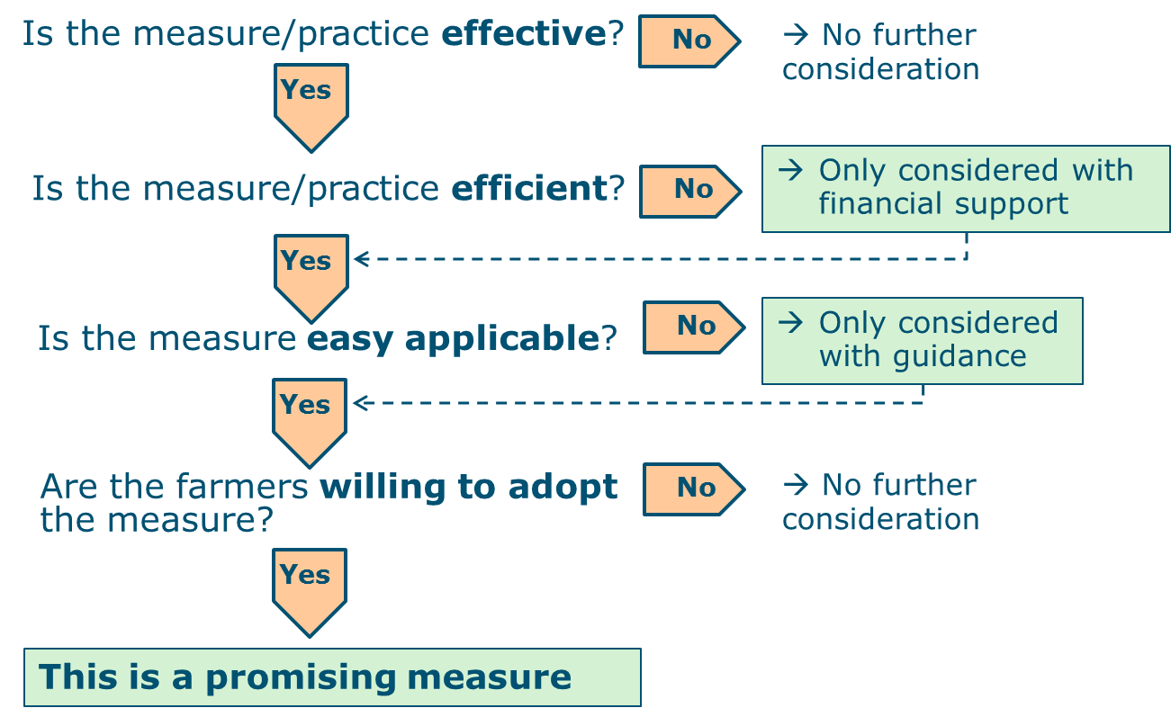
Figure 1. General outline of the framework for the identification of most promising measures and practices.
The third factor is the ‘applicability’ of the measures and practices. Applicability relates to the appropriateness or suitability or feasibility of the measures in practice. Two aspects need to be considered here. First, is the addressee capable and able to implementing/applying the measure, i.e., does he or she has the knowledge and tools to implement the measure in the proper way and at the proper time? Second, do the prevailing socio-economic and environmental conditions allow the implementation of the measure, i.e., does the society have objections against the proposed measures, and/or do the landscape, soil and hydrological conditions provide constraints to implementing the measures? Hence, applicability depends on the addressee and on the site-specific conditions.
The fourth factor is the willingness of addressees to adopt the measures and/or practices (adoptability). Willingness relates to the readiness, eagerness and enthusiasm of the addressee to adopt and implement the measures. Willingness greatly depends on the efficiency and applicability of the measure, but also on the notion, personality and conviction of addressees. Willingness can be derived from the degree of compliance of prescribed measures, but also from interviews and game simulations.
Applicability (third factor) and adoptability (fourth factor) are not always easy to disentangle and to distinguish from each other. In relation to the addressee, ‘applicability’ of a measure depends on the capability (knowledge) and ability (availability of the necessary tools) of the addressee, while ‘adoptability’ depends on the applicability and on the notion, personality and conviction of addressee.
The general outline of the framework as presented in figure 1 has a hierarchal structure. Effectiveness is evaluated first, efficiency second, applicability third and then the adoptability. Most promising measures and/or practices are effective, efficient, applicable and easy adoptable. The outline in Figure 1 is meant to present the concept; it presents only ‘yes/no’ options. In reality, there are more colours; there are various possible combinations and hence a wide range of options.
  - Effectiveness
Effectiveness is defined as the degree to which the pollution of groundwater and surfaces waters with nitrate and pesticides is decreased. The most direct indicator for effectiveness is the change in concentration of nitrate and pesticides in groundwater and/or surfaces waters. The change in concentrations are obtained from monitoring data during a certain time period. There is often a delay in the response of a measure due to the occurrence of bio-physical and bio-chemical processes during the transport of the pollutant from the surface soil to the groundwater and/or surface water. The required time period for observing the response of a measure greatly differs between sites, due to spatial differences in the bio-physical and biogeochemical conditions (retention or attenuation) and the volume of groundwater aquifer and surface water bodies (dilution). Hence, a response of measure is often not directly seen in concentration changes. This emphasizes the need for long-term monitoring data, as well the need to have proxy indicators.
A proxy indicator for effectiveness is a decrease in the nitrate and pesticides loading of groundwater and/or surfaces waters. The stronger the decrease in the loading, the more effective the measure. The decrease in the loading of nitrate is often derived from the changes in the nitrogen surplus (N surplus = total N input – total N output via harvested biomass) at the soil surface (in kg/ha/yr); it is assumed that only fractions of the N surplus will end up in the groundwater aquifer and surface water bodies. The decrease in the load of nitrate may be derived also from the changes in the amounts of soil mineral nitrogen in the soil at a specific soil depth. Again, it is assumed that only fractions of the soil mineral nitrogen will end up in the groundwater aquifer and surface water bodies, depending on the retention and attenuation (denitrification, dilution, immobilisation) rates.
Evidently, the most direct indicator for the effectiveness of a measure to decrease nitrate pollution is the actual decrease in the concentration of nitrate in groundwater and/or surfaces waters. However, this decrease may be observed after several years only, and thus requires long-term monitoring. Conversely, proxy indicators for the effectiveness of a measure are changes in soil mineral nitrogen and changes in the nitrogen surplus. These changes can be quantified directly and rather easily, but the ultimate effect of these changes in loading on the concentration of nitrate in groundwater and/or surfaces waters remain uncertain, because it is uncertain how much of the measured N surplus or soil mineral ultimately ends up in groundwater aquifers and/or surfaces water bodies.
Table 1 provides a proposal for the rating of the effectiveness of measures and practices, using three absolute indicators and a relative indicator (percentage change in concentration or loading). Five effectiveness classes (ratings) have been distinguished. Note that a N surplus of 100 kg per ha per year results in the accumulation of mineral N in the upper 1 meter of soil of less than 100 kg per ha, because the losses via ammonia volatilization and denitrification (and leaching to below the upper 1 meter) are in general larger than the net soil N mineralization. The resulting nitrate concentration in the leachate that will ultimately end up in groundwater and surface waters largely depends on the annual rainfall surplus. A rainfall surplus of 50 cm per year and a soil mineral N content of 100 kg per ha, results in a nitrate concentration of 20 mg NO3-N per liter or ~90 mg NO3 per liter. Halving the rainfall surplus roughly doubles the nitrate concentration in the leachate (assuming that all other condition remain the same. A relative decrease in nitrate loading, derived from changes in soil mineral N or from changes in the N surplus seems the most straightforward indicator for comparing the effectiveness of measures between sites and between regions. Such indicator expresses the actual effect of the measure and has no interferences from variations in N loss processes and rainfall surplus between sites. However, it remains a proxy indicator of the changes in concentrations in aquifers and surface waters.

Table 1. Effectiveness rating of measures and practices to decrease nitrate pollution of groundwater and surface waters. Four types of indicators are proposed (see text).
 | Indicators for effectiveness of measures to decrease nitrate pollution
Effectiveness of the measures and practices | Decrease in nitrate concentration of water bodies, mg NO3/liter | Decrease in soil mineral nitrogen, kg/ha | Decrease in nitrogen surplus at the soil surface, kg/ha | Relative decrease in N loading, %
Very high | >10 | >25 | >50 | >25
High | 5-10 | 10-25 | 25-50 | 10-25
Moderate | 2-5 | 5-10 | 10-25 | 5-10
Low | 0.5-1 | 1-5 | 5-10 | 1-5
Insignificant | ≤0.5 | ≤5 | ≤5 | ≤1

Table 2 provides a proposal for the rating of the effectiveness of measures and practices to decrease pesticide pollution. In this case, only a relative decrease in concentration and/or loading is proposed as indicators; this is the most convenient manner as there is no need in this case to specify the many different types of pesticides. Again, five effectiveness classes (ratings) have been distinguished.
Table 2. Effectiveness rating of measures and practices to decrease pesticide pollution of groundwater and surface waters. Two types of indicators are proposed (see text).
 | Indicators for effectiveness of measures to decrease pesticides pollution
Effectiveness of the measures and practices | Relative decrease in concentration in water bodies, % | Relative decrease in loading of water bodies, %
Very high | >25 | >25
High | 10-25 | 10-25
Moderate | 5-10 | 5-10
Low | 1-5 | 1-5
Insignificant | ≤1 | ≤1

  - Efficiency
Efficiency is defined as the ratio of the economic cost and the effect of the measure. Hence, the efficiency of a measure or practice depends on its cost and effectiveness. As effectiveness can be expressed with various indicators (or units; see Tables 1 and 2), efficiency can be expressed also with various indicators (or units). The costs are in euro per ha per unit change in nitrate concentration or N loading (Table 3).
Five efficiency classes (ratings) have been distinguished. When costs increase, efficiency goes down, and vice versa. A very high efficiency is beneficial for the addressee; a decrease in nitrate concentration or N loading is associated with an increase in crop yield and/or quality (probably because there was excess N fertilization), and/or with a decrease in cost of inputs (fertilizers, pesticides).
It is assumed that the efficiency is insignificant when the cost are 100 euro per ha per kg N surplus and/or per kg soil mineral N, and/or per mg NO3 per liter, and/or per % change in N loading. As indicate before, it may be easier to realize a 1 % change in N loading than a decrease of the nitrate concentration of 1 mg per liter of an aquifer or water body. Hence, the cost should be made site-specific and also indicator-specific in the end.
Table 3. Efficiency rating of measures and practices to decrease nitrate pollution of groundwater and surface waters. Four types of indicators are proposed (see text).
Efficiency of the measures and practices | Economic cost of the measures, in euro per ha and per unit decrease in nitrate pollution of groundwater and/or surface waters
 | Euro per ha and per mg NO3 per liter | Euro per ha and per kg soil mineral N | Euro per ha and per kg N surplus | Euro per ha and per 1 % change in N loading
Very high | ≤0 | ≤0 | ≤0 | ≤0
High | 0-25 | 0-25 | 0-25 | 0-25
Moderate | 25-50 | 25-50 | 25-50 | 25-50
Low | 50-100 | 50-100 | 50-100 | 50-100
Insignificant | >100 | >100 | >100 | >100

Table 4 provides a proposal for the rating of the efficiency of measures and practices to decrease pesticide pollution. In this case, the economic cost of a relative decrease in concentration and/or loading is proposed as indicators; this is the most convenient manner as there is no need in this case to specify the many different types of pesticides. Again, five effectiveness classes (ratings) have been distinguished.
Table 4. Efficiency rating of measures and practices to decrease pesticide pollution of groundwater and surface waters. Two types of indicators are proposed (see text).
 | Economic cost of the measures, in euro per ha and per unit decrease in nitrate pollution of groundwater and/or surface waters
Effectiveness of the measures and practices | Euro per ha and per 1 % decrease in pesticide concentration in water bodies | Euro per ha and per 1 % change in pesticide loading to water bodies
Very high | ≤0 | ≤0
High | 0-25 | 0-25
Moderate | 25-50 | 25-50
Low | 50-100 | 50-100
Insignificant | >100 | >100

  - Applicability
Applicability relates to the appropriateness or suitability or feasibility of the measures in practice. As indicated before, two aspects need to be considered here. First, is the addressee capable and able of implementing/applying the measure. Second, do the prevailing socio-economic and environmental conditions allow the implementation of the measure.
The capability and ability of the addressee depend on the education level (does the addressee have the necessary information and data to implement the measure) and on the instrumentation (does the addressee have the necessary tools, machines, techniques, labour to implement the measure. These aspects can be assessed through surveys and stakeholder dialogues, by raising two questions: (i) does the addressee have the necessary data and information for implementing the measure, and (ii) does the addressee have the necessary tools, machines, techniques, labour to implement the measure?
Socio-economic and environmental constraints for implementing measures relate to possible societal, juridical, legal, geomorphological, landscape, soil and climate barriers that obstruct the implementation of measures in practice. For example, changing land use to high-yielding bio-energy crops may evoke objections from citizens, growing cover crops may not be feasible from rotation and/or climate points of view, establishing riparian zones may raise health concerns by citizens because of the associated increase in flies or brown rats. These aspects can be assessed through surveys and stakeholder dialogues, by raising two questions: (i) does the society at large have possible objections against the proposed measure, and (ii) does the land, soil, crop rotation, climate allow the implementation of the proposed measures?
Table 5 presents a proposal for an applicability assessment of possible measures and practices to decrease nitrate and pesticide pollution of groundwater and surface waters. Three classes have been distinguished for the assessment of possible applicability constraints.
Table 5. Addressing the applicability of measures and practices to decrease nitrate and pesticide pollution of groundwater and surface waters.
 | Applicability assessment
Questions to addressees related to the applicability of measures | No constraints | Some constraints | Severe constraints
Do addressees have the necessary data and information | Yes | partly | No
Do addressees have the necessary tools, machines, techniques | Yes | partly | No
Does the society at large have possible objections | No | partly | Yes
Does the land, soil, crop rotation, climate allow the implementation of the measures | Yes | partly | No

  - Willingness
The willingness of the addressees to adopt the measures and/or practices (adoptability), depends on the efficiency (cost-effectiveness) and applicability of the measure, but also on the notion, personality and conviction of addressees. When measures are evaluated as efficient and applicable in practice (according to the criteria outlined before), most addressees will implement the measures, but not all. The addressees not implementing efficient and applicable measures may perceive farm-specific and/or personal objections against implementing proposed measures. Such objections can be diverse. Incentives from an actor (persuasion, subsidies, fines) may remove most objections. Yet, society must accept that the willingness to implement measures may meet resistance from some addressees, so that 100% compliance will not be achieved easily. Involvement of addressees in an early stage in the development of measures may help.
Willingness (adoptability) can be addressed through surveys and stakeholder dialogues. Table 6 presents a proposal for an assessment of the willingness of addressees to implement possible measures and practices to decrease nitrate and pesticide pollution of groundwater and surface waters.
Table 6. Addressing the willingness of addressees to implement measures and practices to decrease nitrate and pesticide pollution of groundwater and surface waters.
 | Assessment of the willingness of addressees to implement measures
Questions to addressees related to the willingness to implement measures | High | Moderate | Low
Are the proposed measure(s) applicable on the farm | yes | possibly | no
What are the perceived efforts and cost related to the implementation of the proposed measure? | small | medium | large
Are there (other) objections to implement the proposed measure? | No | Maybe | yes

- Framework for the identification of most promising measures
Most promising measures to decrease nitrate and pesticides pollution of groundwater and surface waters are defined as ‘effective, efficient and easy applicable measures that addressees are willing to implement’. Most promising measures may refer to just one measure or to a package of measures. As socio-economic and environmental conditions greatly vary across the EU, there may be different most promising measures for different regions. The identification and assessment of most promising measures therefore requires region-specific analyses.
Four indicators are central and universal in the framework for the identification of most promising measures, namely (i) effectiveness, (ii) efficiency, (iii) applicability, and (iv) adoptability (or willingness of the addressees to implement proposed measures). Effectiveness is most important and comes first (Figure 1), as it make little sense to further consider measures that do not contribute to the objectives of decreasing nitrate and pesticides pollution of groundwater and surface waters. Hence, effectiveness first.
The indicators efficiency, applicability and adoptability are often strongly related. When the cost of a measure is high and the applicability low, adoptability will be low, and vice versa. This suggests that the order of evaluation/assessment of these indicators is not very critical. There are reasons to suggest to continue first with efficiency (after the effectiveness assessment) and there reasons to suggest to first continue with adoptability. The order of assessment in figures 1 and 2 puts the focus first on natural sciences aspects and then on social aspects. The region- and site-specificity of the measures is relevant for all four indicators, because of the spatial variation in socio-economic and environmental conditions.
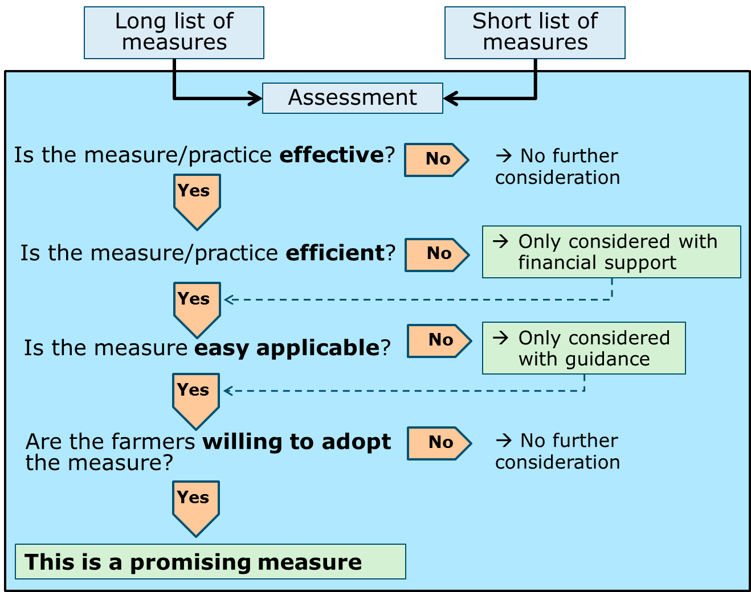
Figure 2. Framework for the identification of most promising measures from the long list and short list of the literature reviews and analyses of work package 4 (see text)
The tables 1 to 6 are an integral part of the framework, as the information in the tables provides the nuances needed to assess and identify the most promising measures. Measures that are moderately effective (Table 1) can in the end be identified as promising measure because of the efficiency, applicability and adoptability. Conversely, measures that are effective may not be the most promising measure because of constraints related to cost, applicability and adoptability.
The framework will be used for the identification and assessment of measures described in literature. The review in Work package 4 of FAIWAY yields a so-called long list of measures and a short list of measures. The long list contains an overview of all possible measures; the short list contains a list of measures that have been examined in much greater detail on the basis of quantitative data. Measures of both lists may be assessed further using the framework presented here. Next, measures will be tested at the case study sites of work package 2, and incorporated in the decision support tools developed in work package 5 to facilitate the further implementation in practice.

